Cognizant Technology Solutions



A Project Report on

“WEBSITE TRAFFIC ANALYSIS”

By

|  |  |
| --- | --- |
| Adarsh P | 2320771 |
| Amritha Narayanankutty | 2320932 |
| Digvijay Patil | 2320451 |
| Naguru Mounika | 2320670 |
| Naga Phani Narina | 2320859 |
| Prajwal C Mannangi | 2320570 |
| Pratik Patil | 2320814 |

**REQUIREMENTS:**

* Collect website traffic logs and import them into Amazon Redshift.
* Analyse user behaviour by calculating metrics such as page views, unique visitors, and bounce rates.
* Identify popular pages and traffic sources by analysing referral URLs and page visit patterns.
* Determine peak traffic times by analysing traffic patterns over different time periods (e.g., hourly, daily).
* Optimize website performance based on insights from traffic analysis.
* Visualize website traffic data using charts and graphs (e.g., line graphs, heatmaps) to understand user behaviour and traffic patterns.
* **REQUIREMENT 1:** **Collect website traffic logs and import them into Amazon Redshift.**

Amazon Redshift is a powerful, fully managed data warehouse service that operates at a petabyte scale. It simplifies data analysis using your existing business intelligence tools.

**Prior Requirements:**

The process of loading Data into the Amazon RedShift from S3 are shown below.

Create IAM Permission

Create S3 Bucket

Load The Data.

Create Redshift Cluster

**4**

**3**

**2**

**1**

**1. Creating S3 Bucket:**

**a) Open the S3 Console:**

* First, navigate to the Amazon S3 console.
  + - * You can find it by searching for “S3” in the AWS Management Console

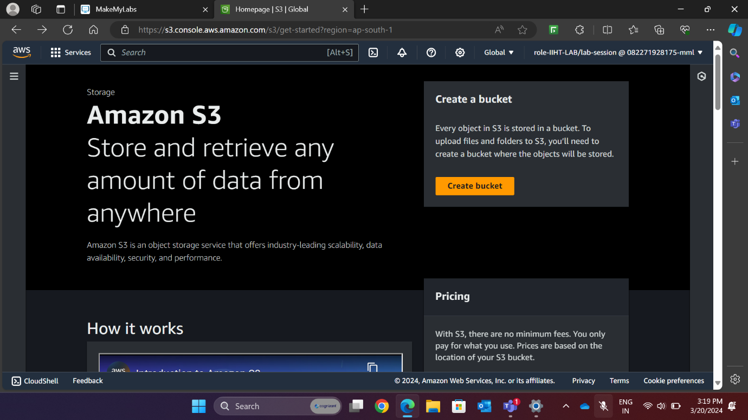

Fig1: Aws S3 console

**b) Create a Bucket:**

* Click on the “Create Bucket” button.
* A new window will open, as shown in the figure below (Fig. 2).

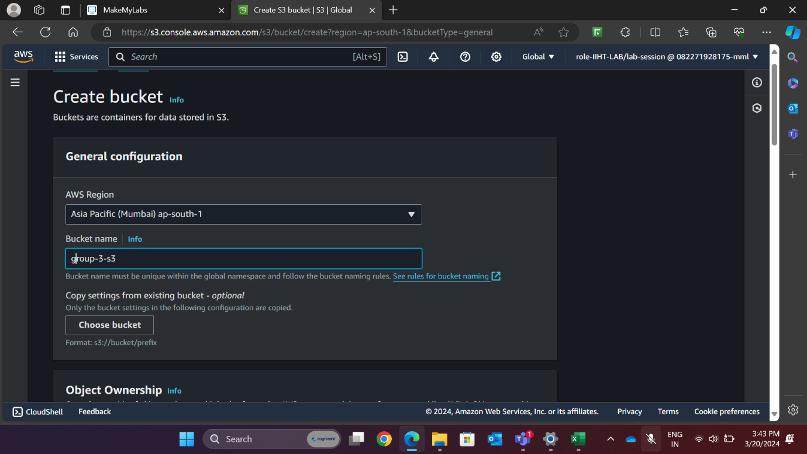

Fig 2: Aws S3 console

**c) Configure Bucket Settings:**

* Provide the AWS region name, such as “Asia Pacific (Mumbai) (ap-south-1)”.
* Choose a unique Bucket name.
* Decide on the object ownership (who can access the objects). For this example, we’ll go with ACLs disabled.
* Enable or disable public access based on your requirements.
* Optionally, enable Bucket versioning to keep multiple variants of objects in the same bucket.

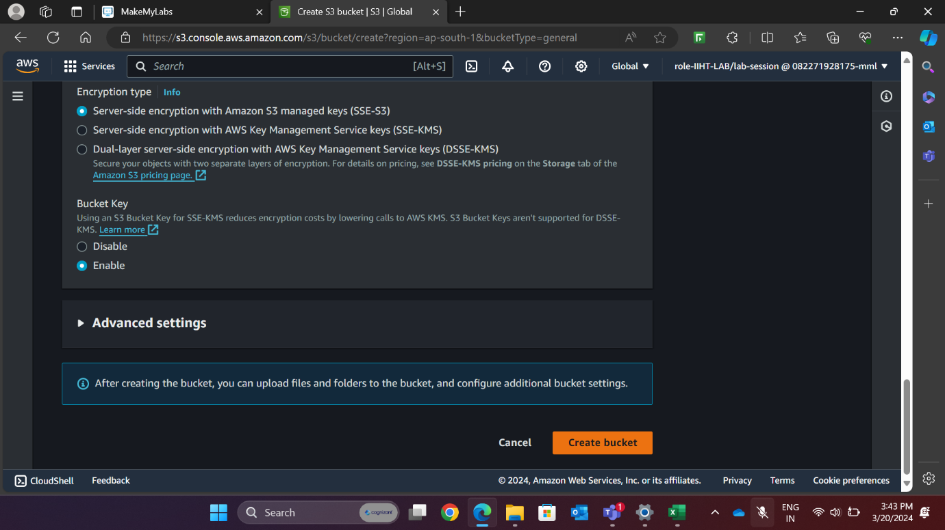

Fig 3: Aws S3 console

**d) Create the Bucket:**

* Finally, use the “Create Bucket” option to create your S3 bucket.

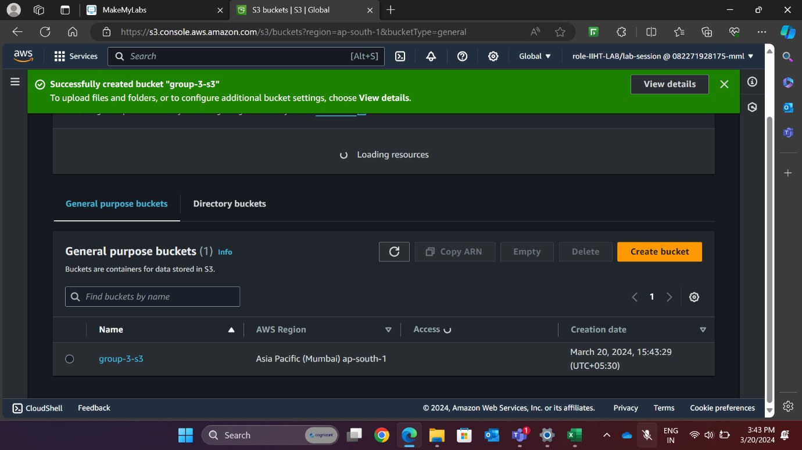

Fig 4: Aws S3 console

**2. Create IAM Permission:**

**a)** **Open the IAM Console:**

* Navigate to the AWS Identity and Access Management (IAM) console.
* You can find it by searching for “IAM” in the AWS Management Console.

**b) Create a Role:**

* Click on “Roles” in the left navigation pane.
* Select “Create role.”
* In the “Use case” section, choose “Redshift.”

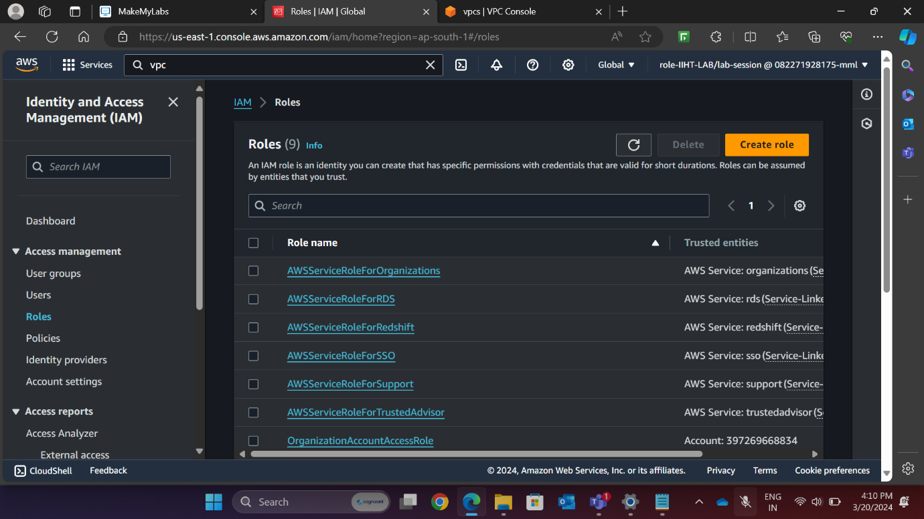

Fig 5: Aws IAM dashboard

**c) Configure Role Settings:**

* Choose “Redshift - Customizable” for specified services.

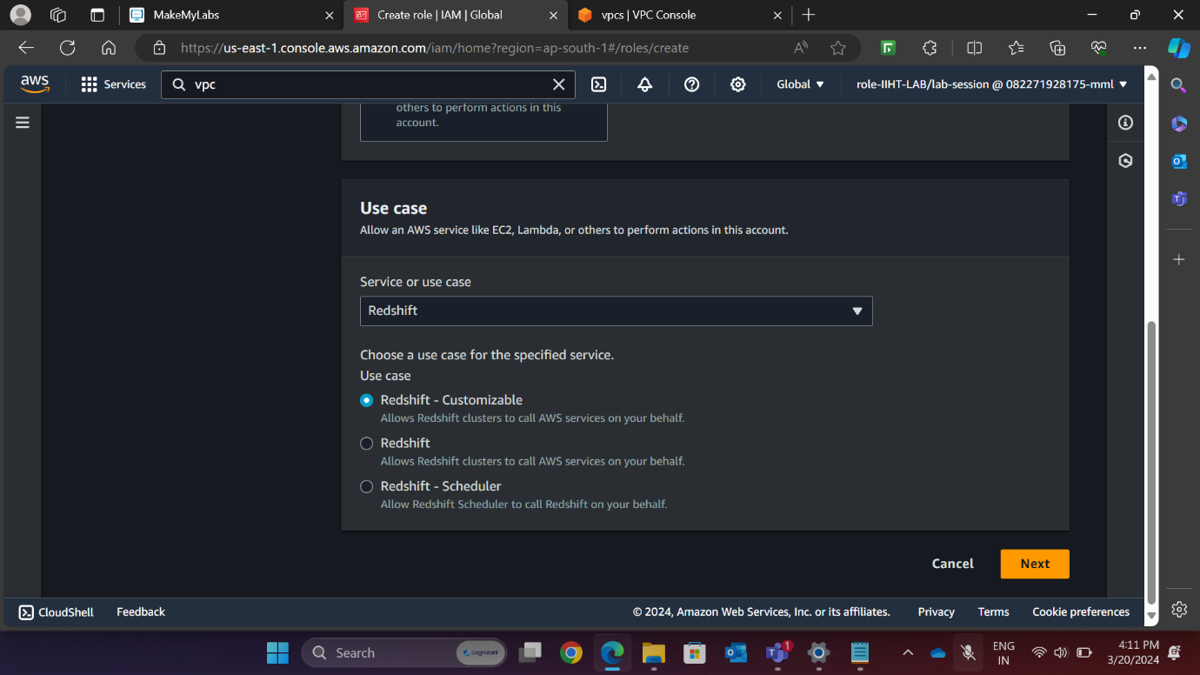

Fig 6: Aws IAM dashboard

**d) Choose Permissions:**

* In the permissions section, select “S3 Full Access” (or customize permissions as needed).

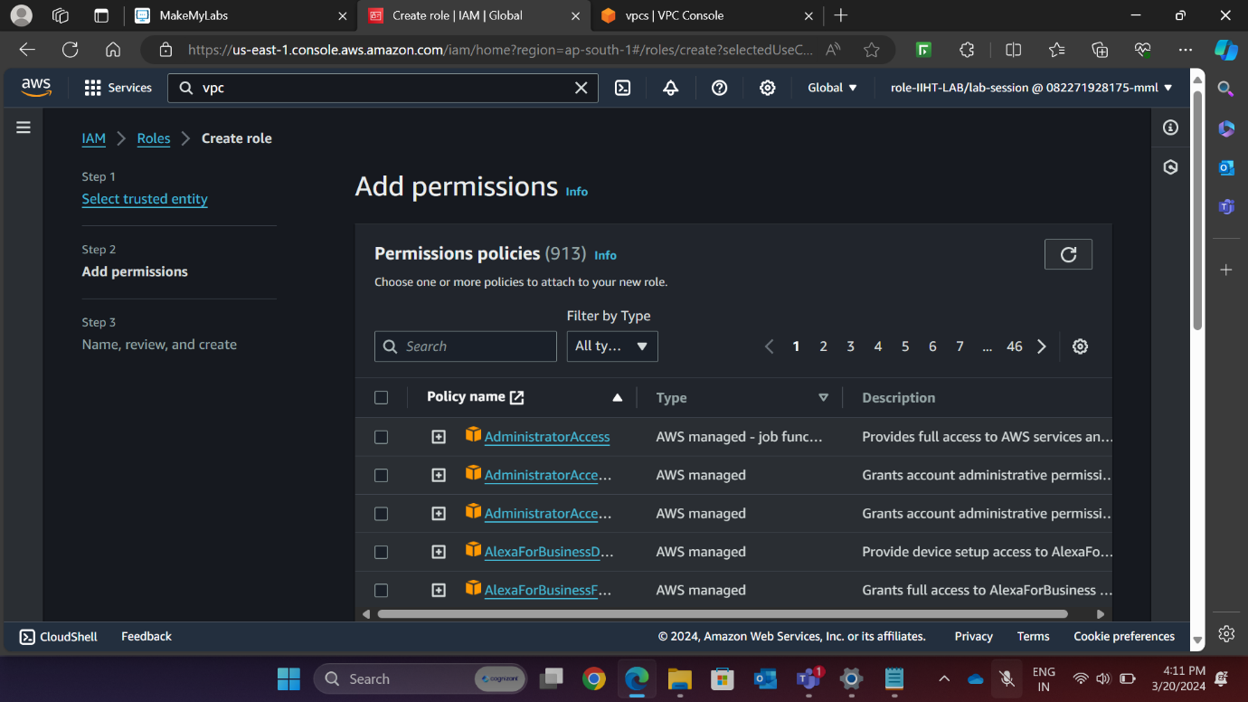

Fig 7: Aws IAM dashboard

**e) Provide Role Details:**

* Enter a role name and description.
* Click on “Create role”.

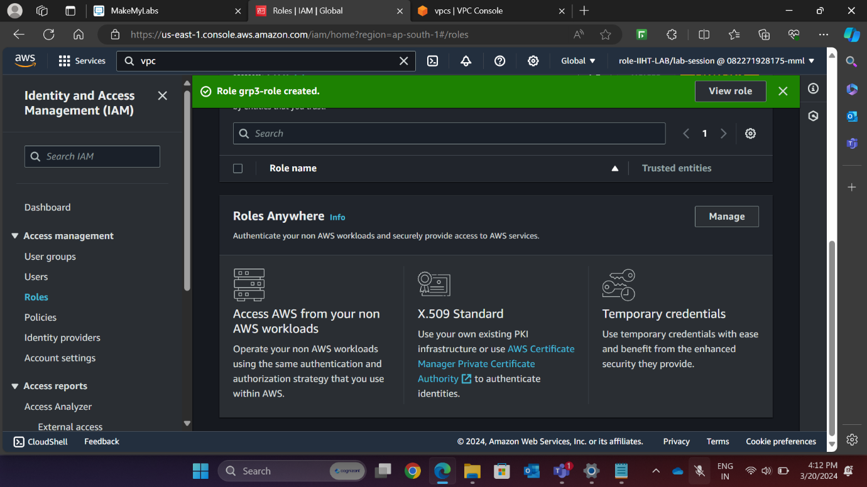

Fig 8: Aws IAM dashboard

**3. Creating a RedShift Cluster:**

**a) Open the Amazon Redshift Console:**

* Navigate to the AWS Management Console.
* Search for “Redshift” and click on “Amazon Redshift”.

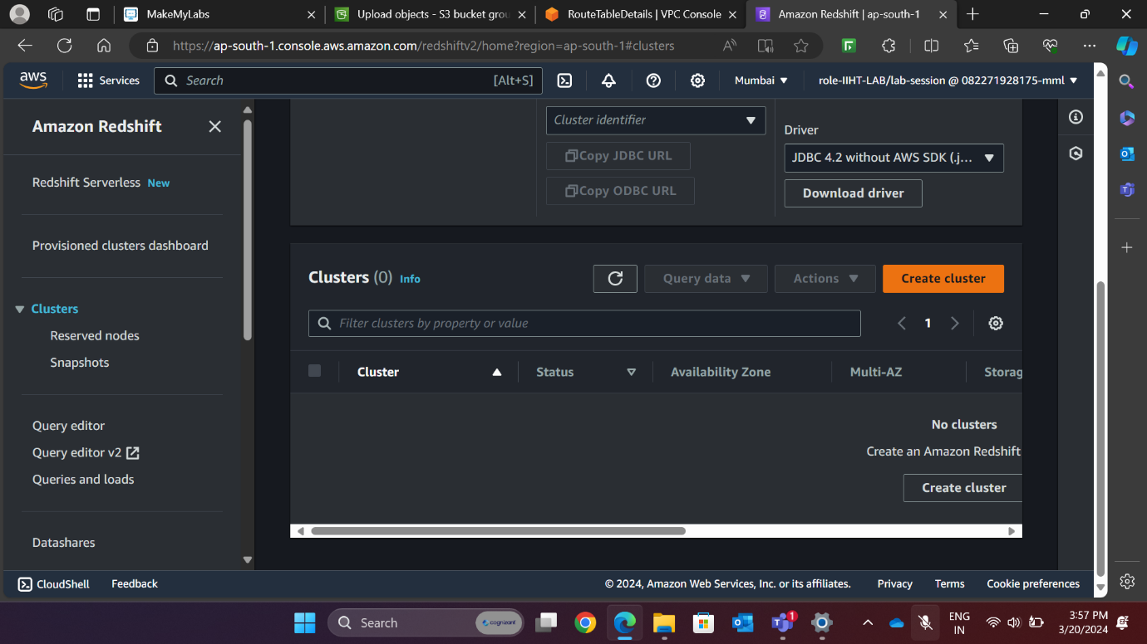

Fig 9: Aws Redshift console

**b) Create a Cluster:**

* Click on “Create cluster.”
* Provide necessary information:
* Cluster identifier (e.g., “grp3-cluster”)
* Node type (e.g., “dc2.large”)
* grp3 username
* password
* Configure VPC settings (if applicable)
* Set up security group settings.
* Click on “Create cluster.”

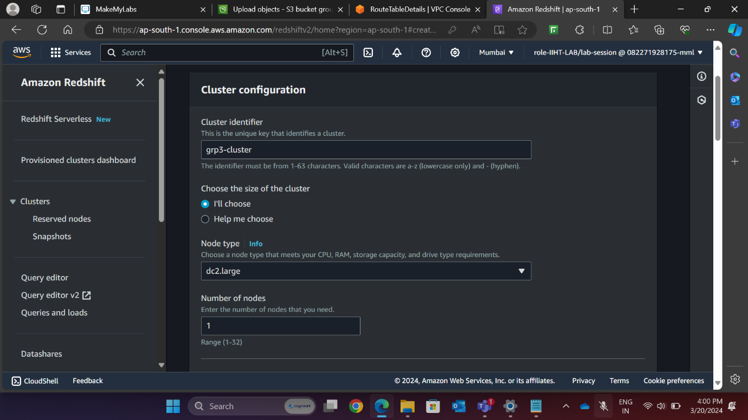

Fig 10: Aws Redshift console



Fig 11: Aws Redshift console

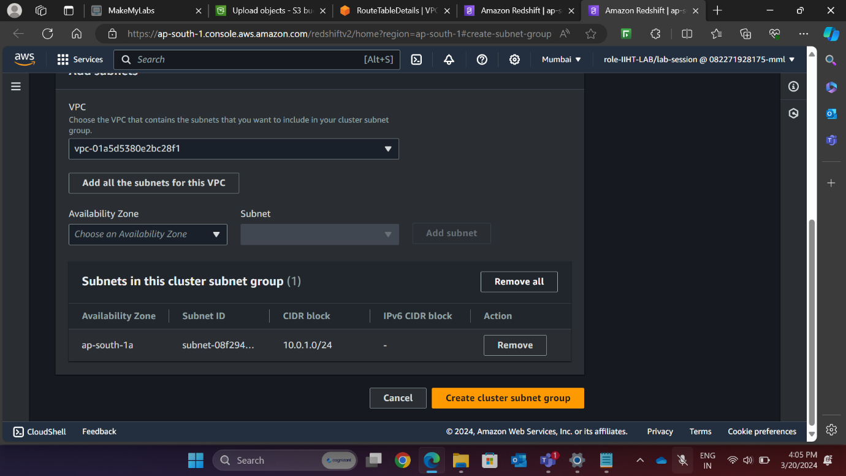

Fig 12: Aws Redshift console

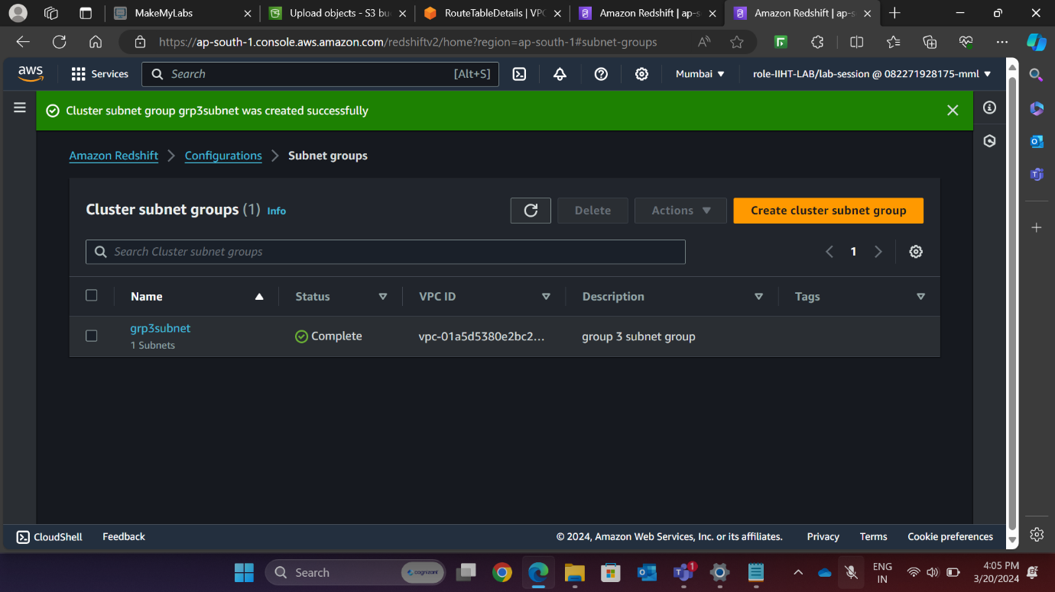

Fig 13: Aws Redshift console

**c) Attach an IAM Role:**

* After the cluster is created, select your cluster from the list.
* Go to the “Cluster properties” tab.
* Click on “Associate IAM Role” to attach an existing IAM role.
* Select the IAM role that you’ve already created.

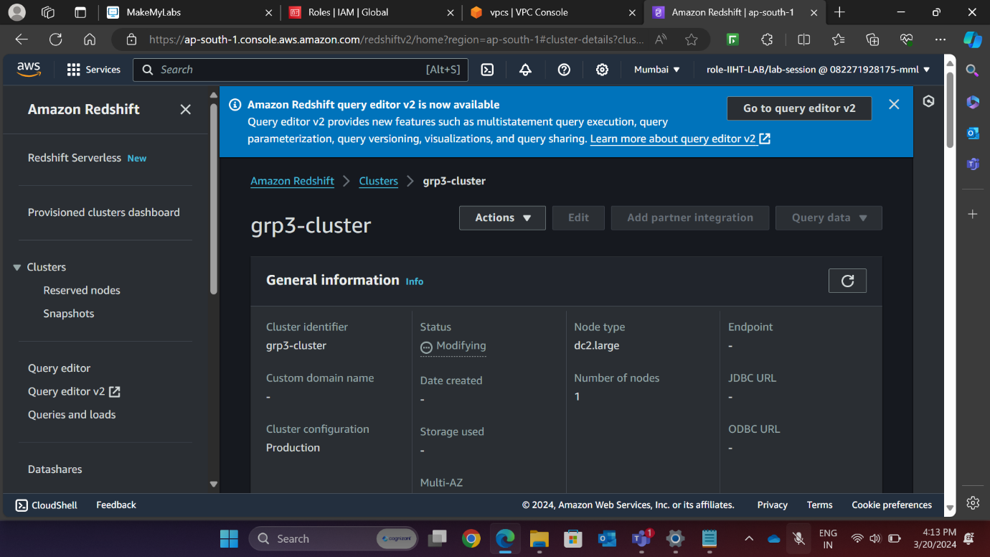

Fig 14: Aws Redshift console

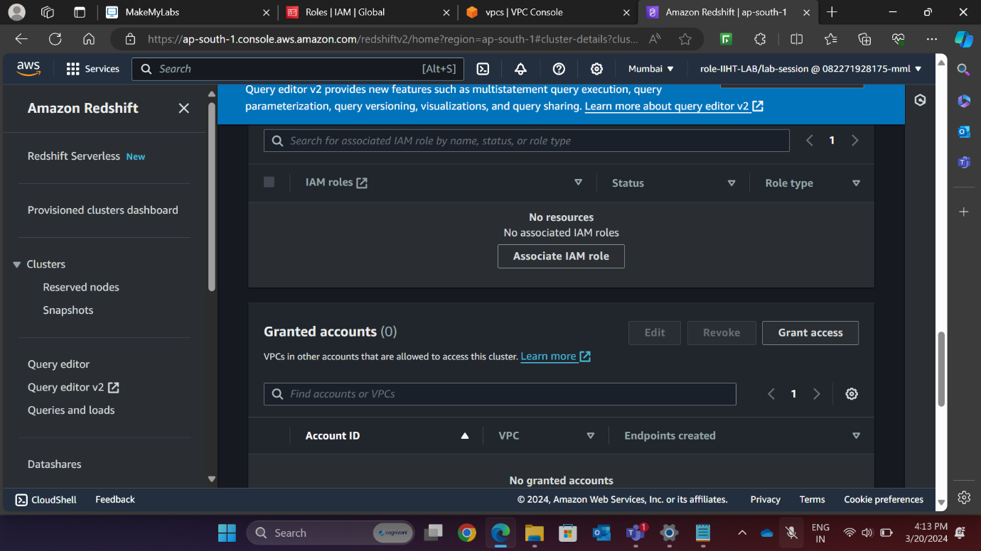

Fig 15: Aws Redshift console

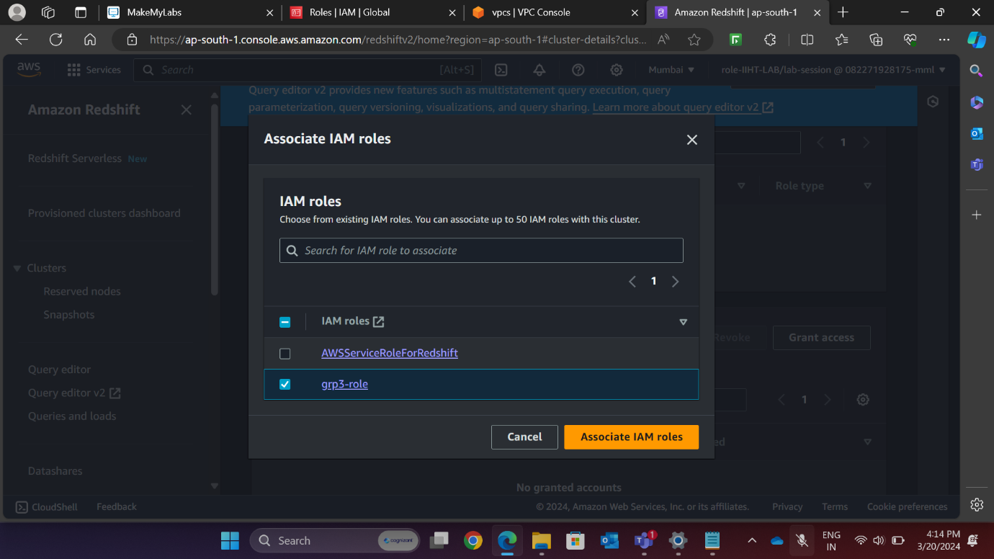

Fig 16: Aws Redshift console

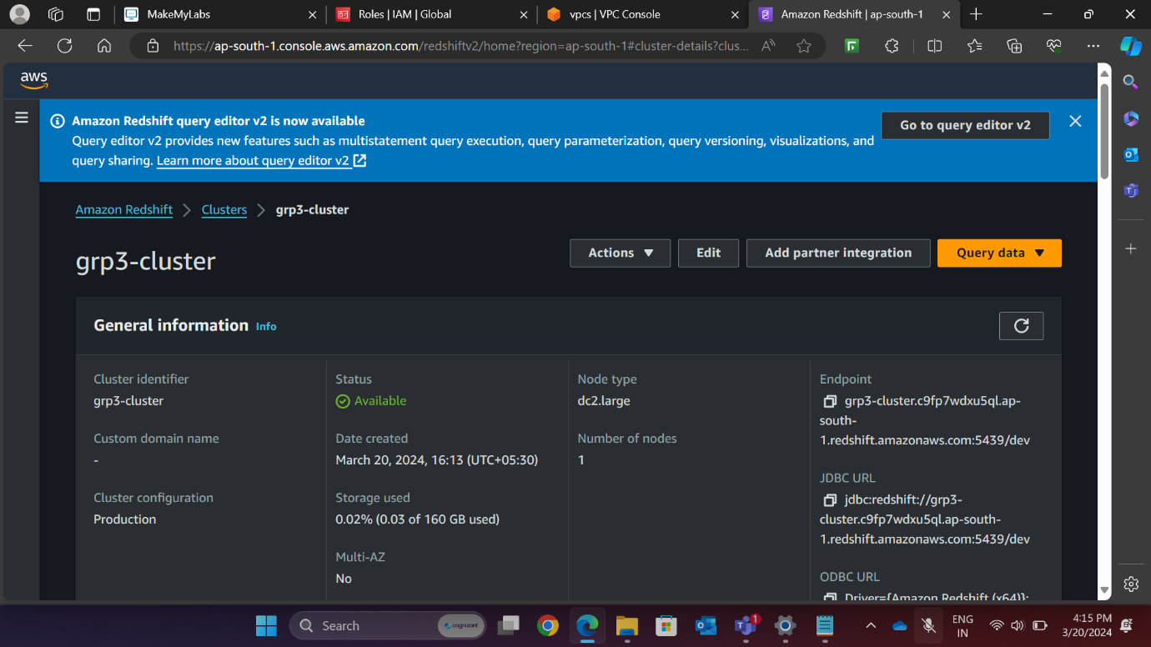

Fig 18: Aws Redshift console

**4. Loading the Data:**

**a)** **Load Data from Local Machine to S3 Bucket:**

* Open the Amazon S3 console.
* Click on your S3 bucket.
* Look for the “Upload” option in the “Objects” section.
* Click on “Upload.”
* Add files or folders from your local machine.
* Select your data sheet and upload it to the S3 bucket.

**b) Load Data from S3 Bucket to Redshift Cluster:**

* Open the Redshift console.
* Go to your Redshift cluster.
* Open the Query Tool (Redshift Query Editor v2).
* Use the “LOAD DATA” option to load data from S3.
* Browse and select the data from your S3 bucket.

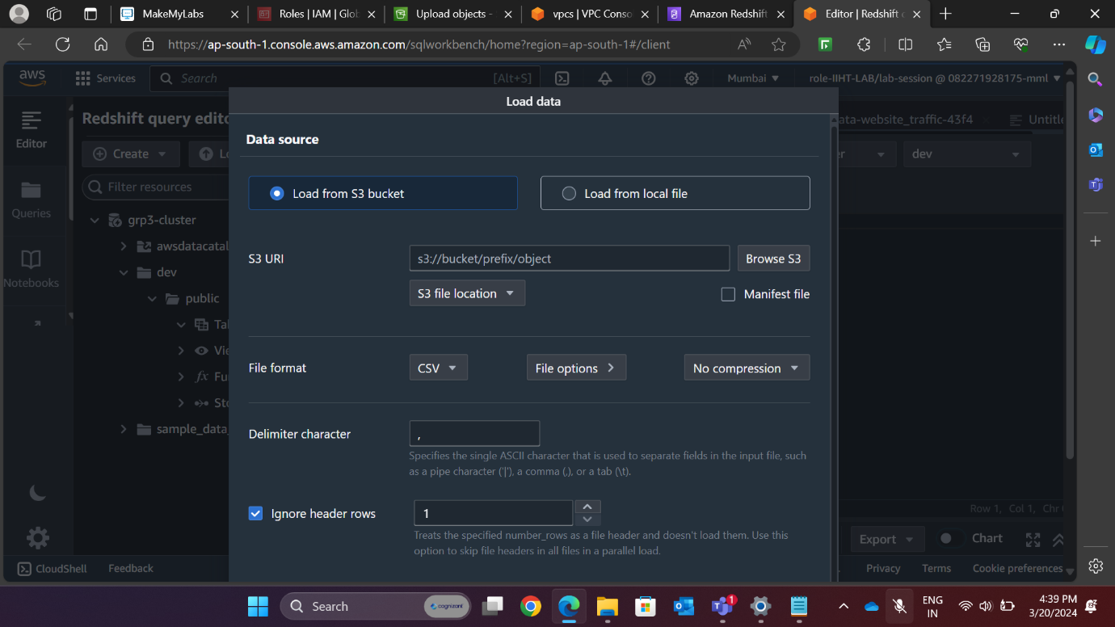

Fig 18: Aws Redshift Query console

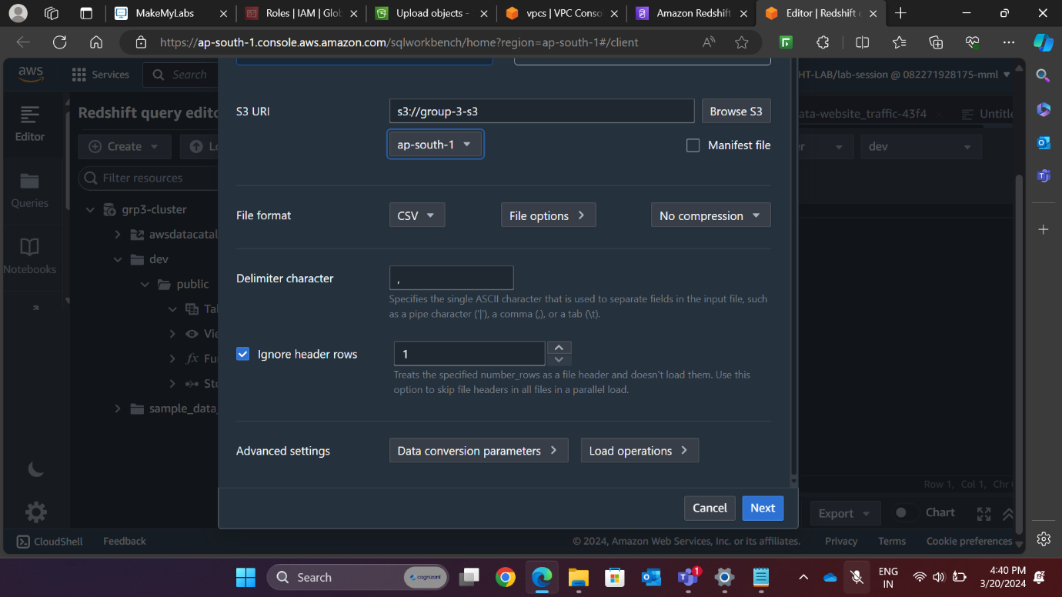

Fig 19: Aws Redshift Query console

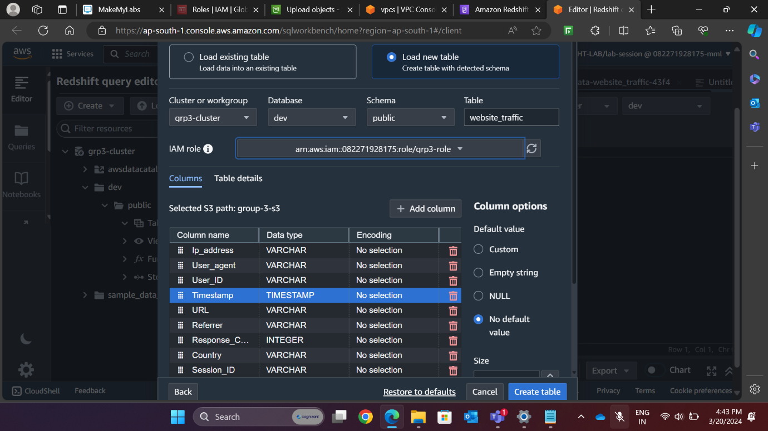

Fig 20: Aws Redshift Query console

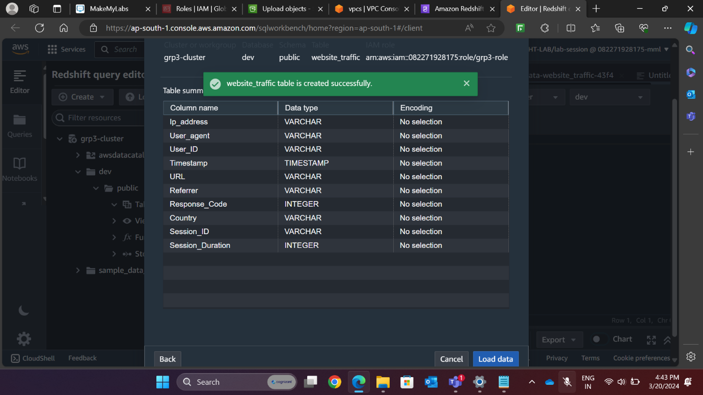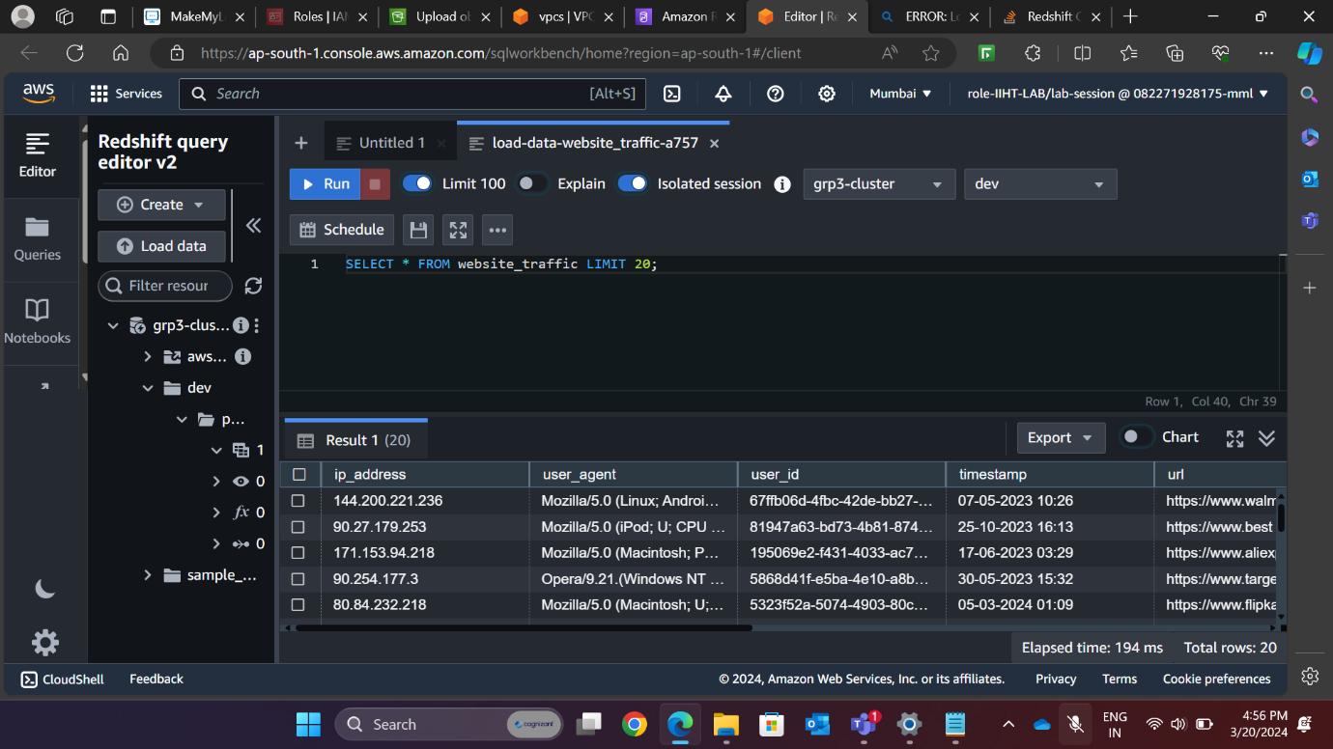

**REQUIREMENT 2: Analyse user behaviour by calculating metrics such as page views, unique visitors, and bounce rates.**

1. **Calculate Page Views for website traffic Analysis.**

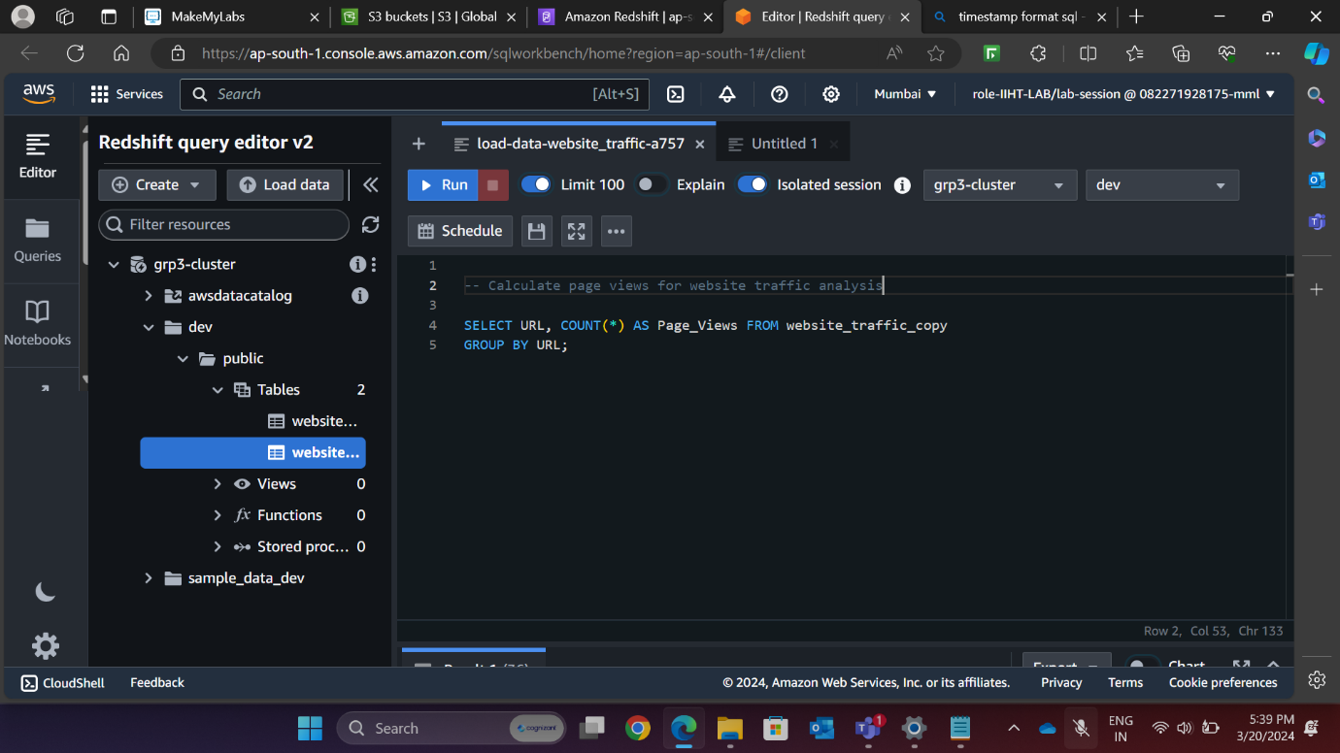

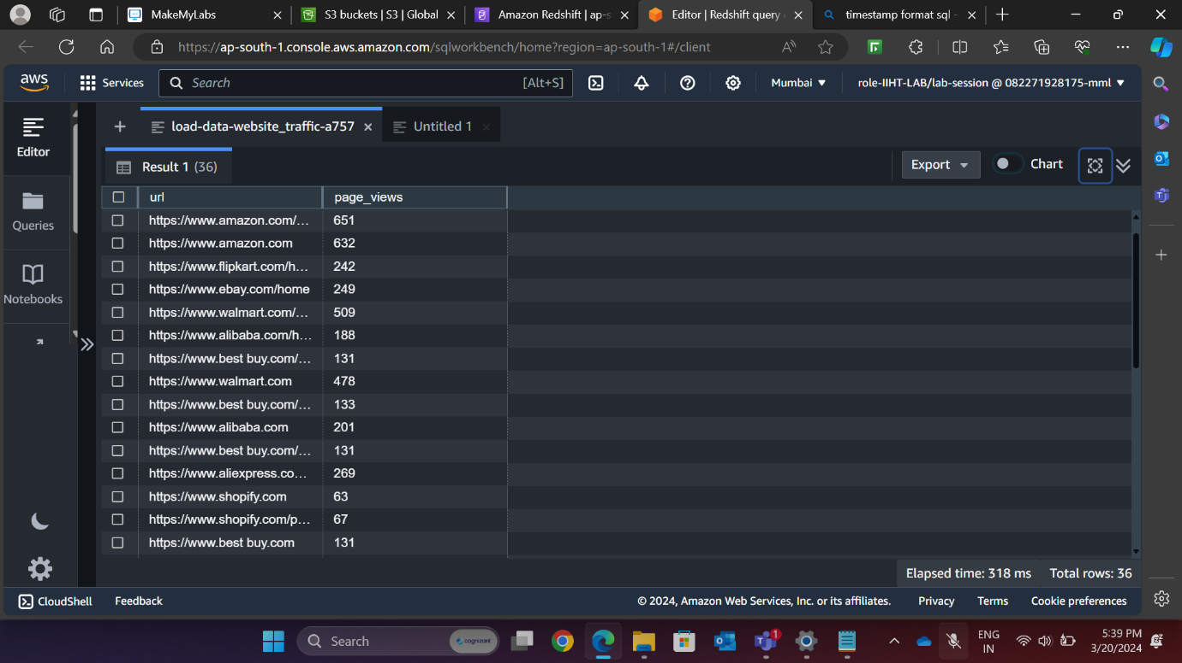

**B) Calculate Unique Visitors**

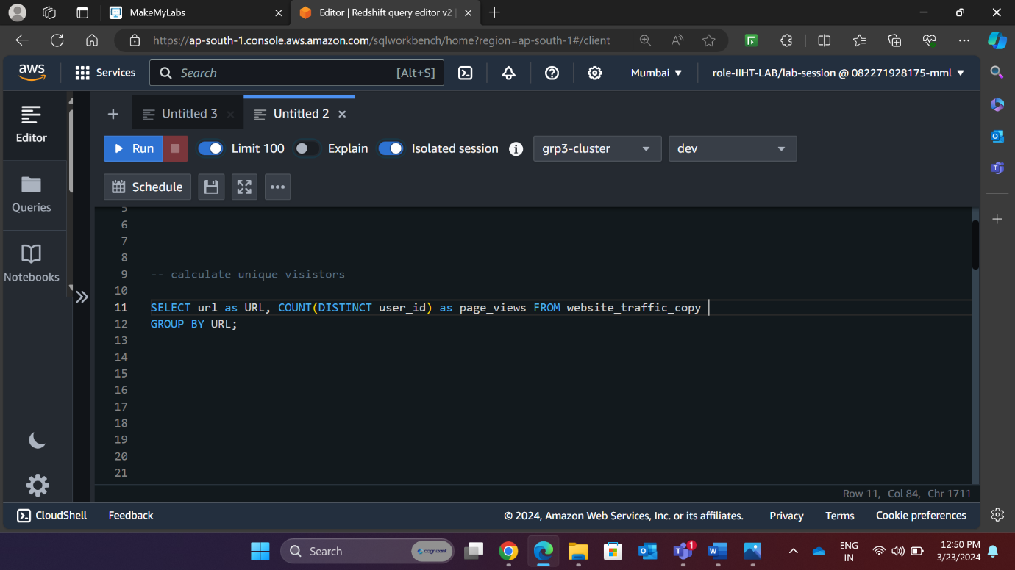

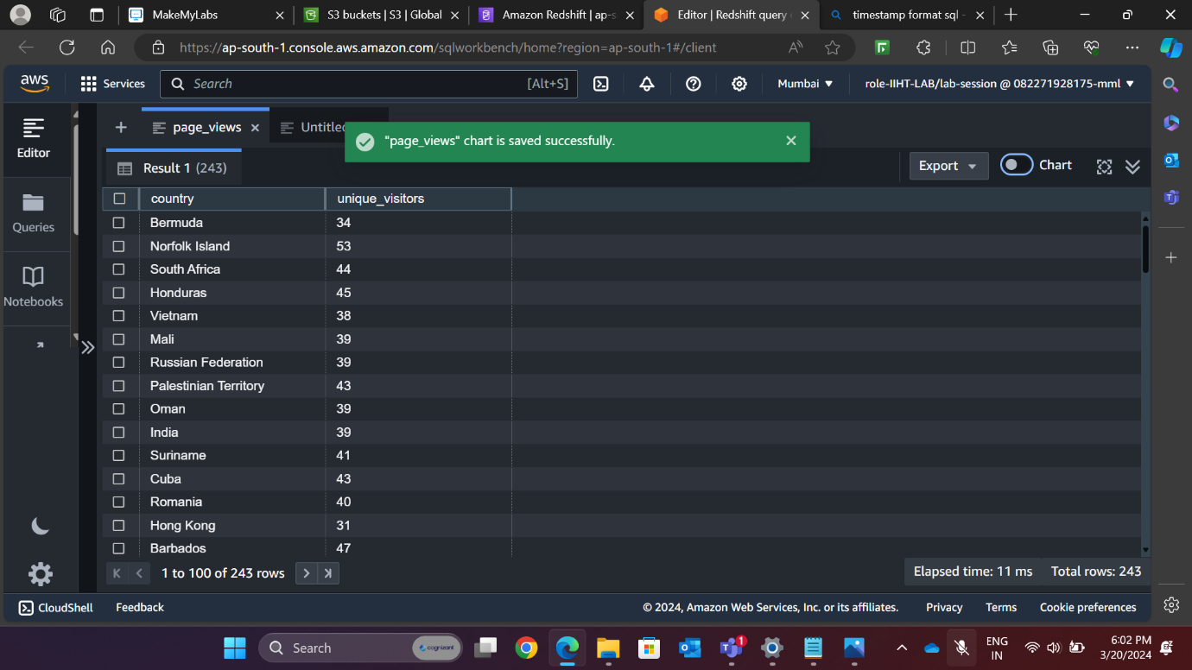

**C) Calculation of Bounce Rate**

**Bounce Rate:** The percentage of visitors to a particular website who navigate away from the site after viewing only one page

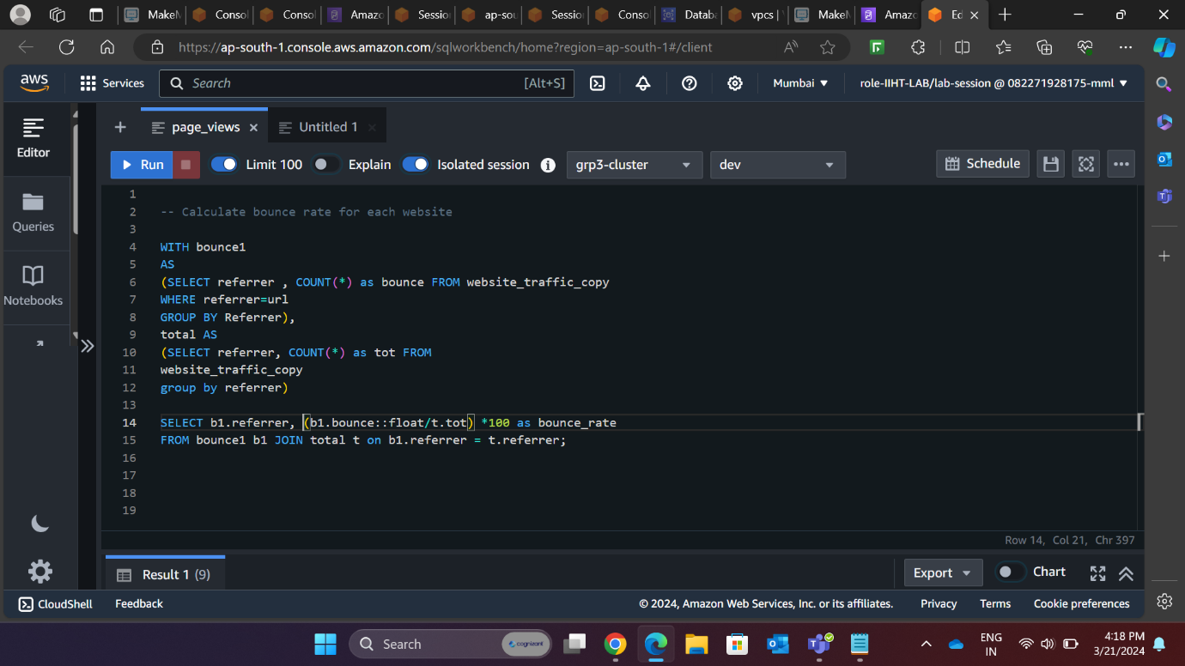

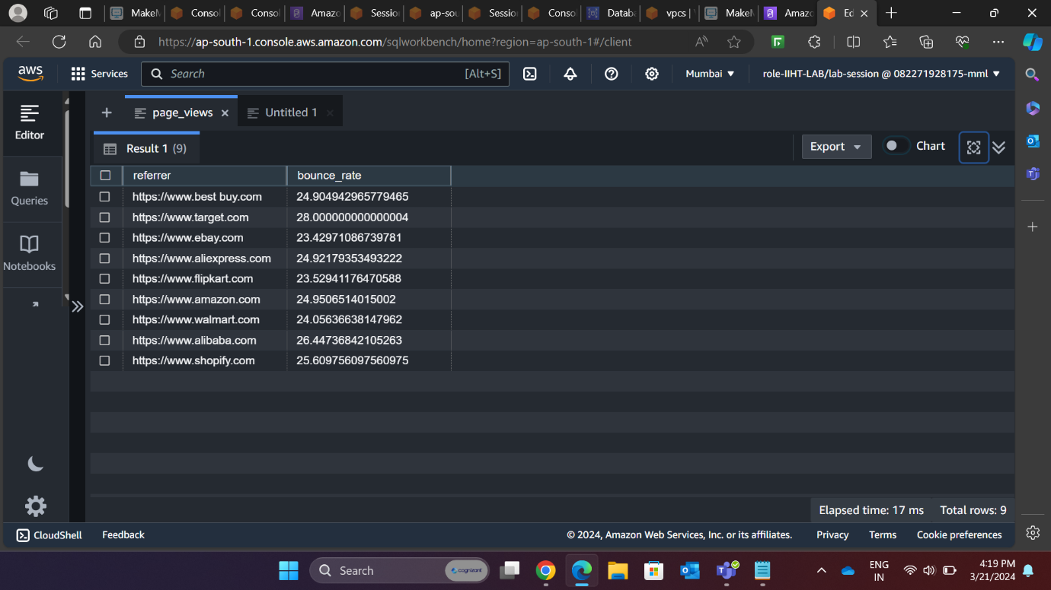

* **REQUIREMENT 3: Identify popular pages and traffic sources by analysing referral URLs and page visit patterns.**

1. Analysis of Popular Pages

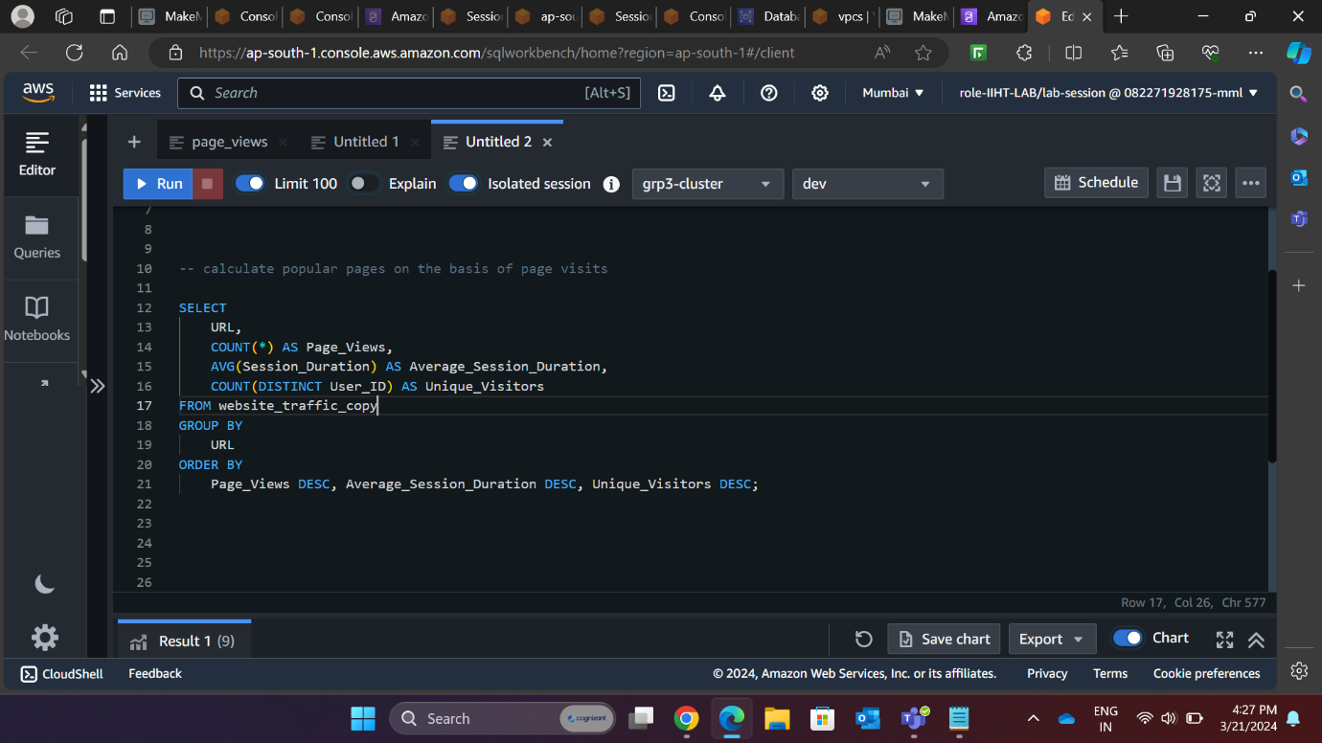

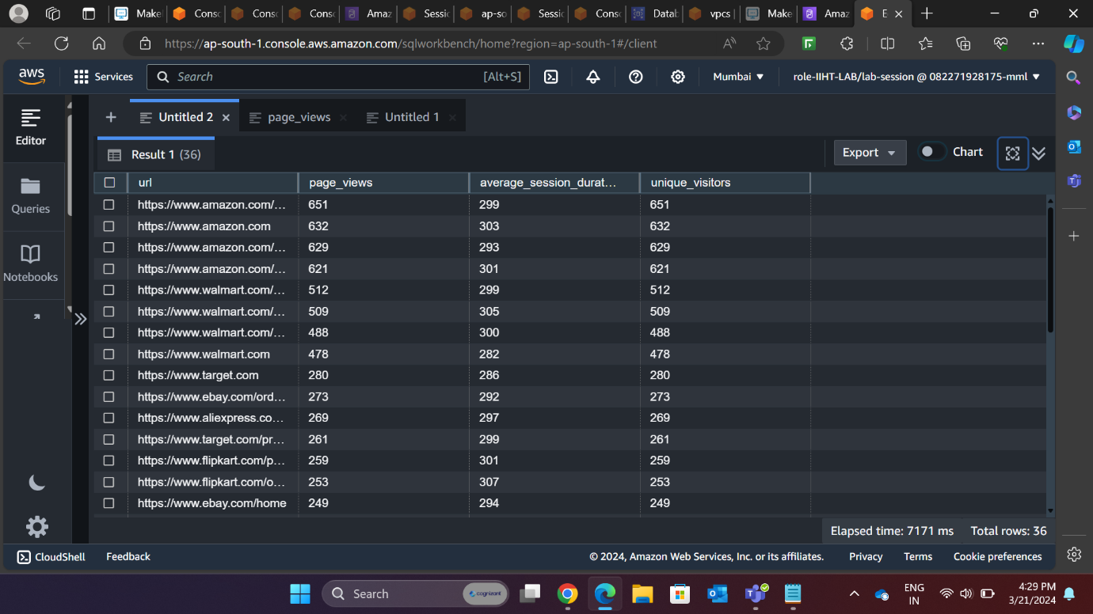

* **REQUIREMENT 4: Determine peak traffic times by analysing traffic patterns over different time periods (e.g., hourly, daily).**

1. Hourly Analysis of Traffic Patterns

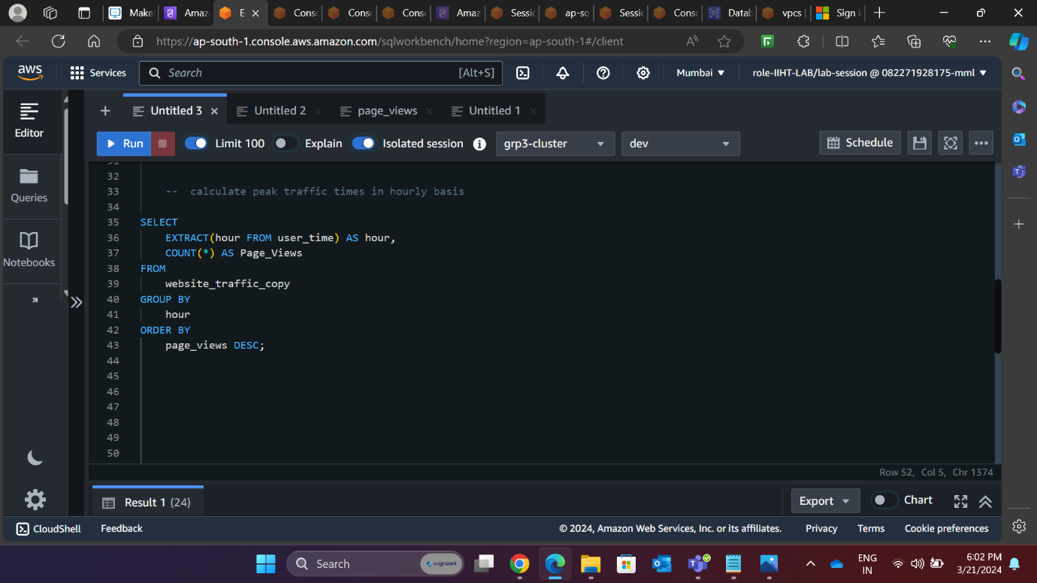

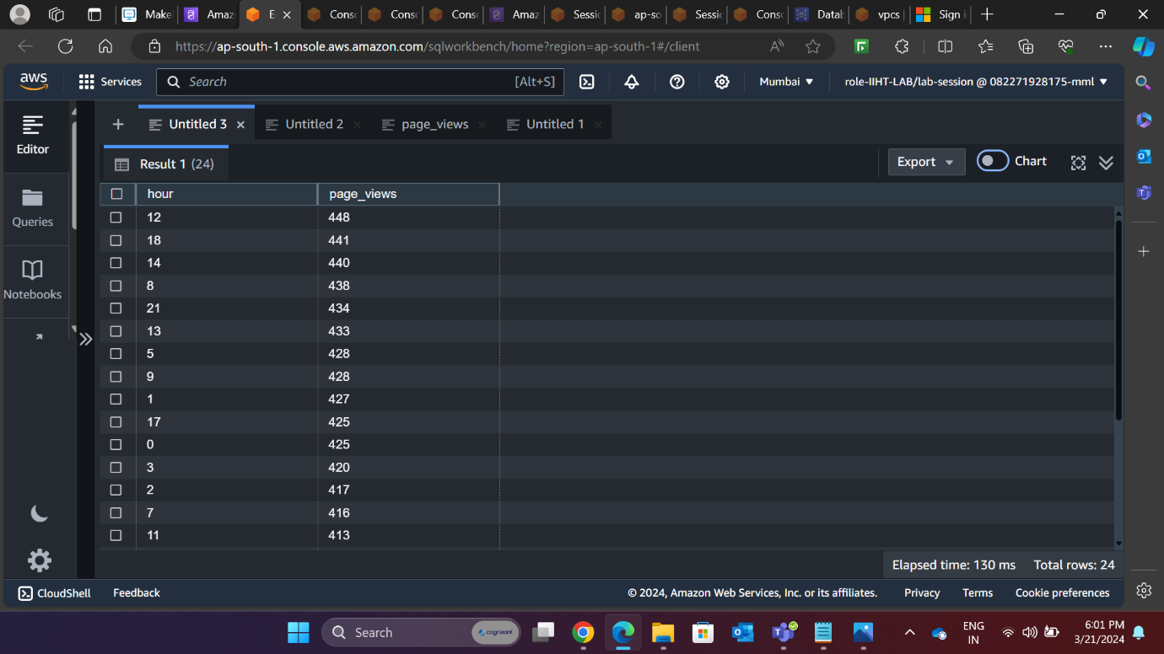

1. **Daily Analysis of Traffic Patterns**

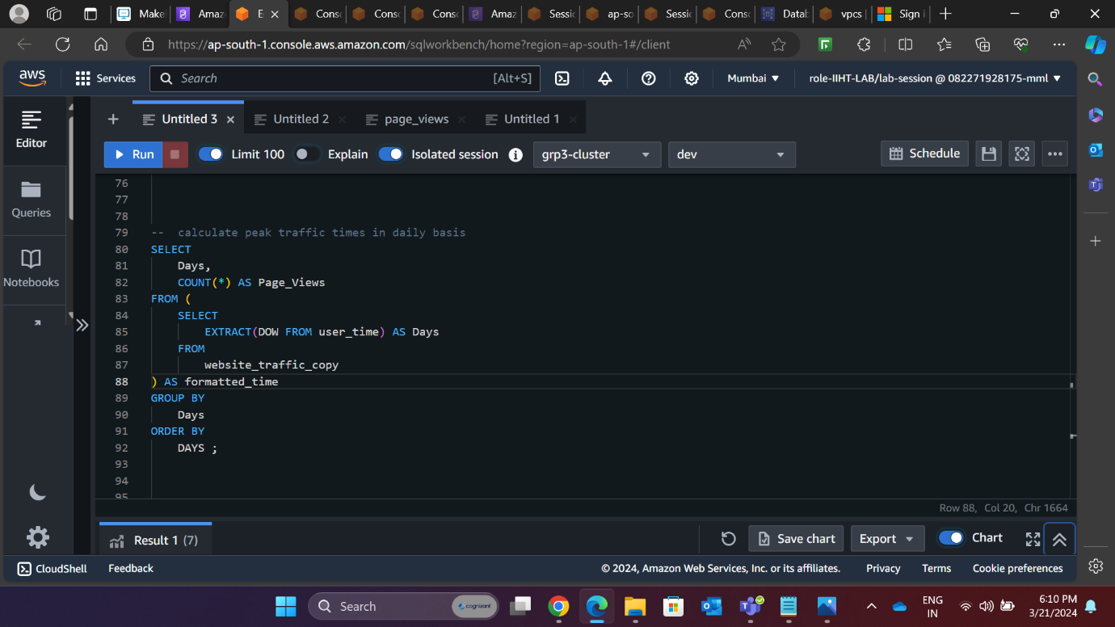

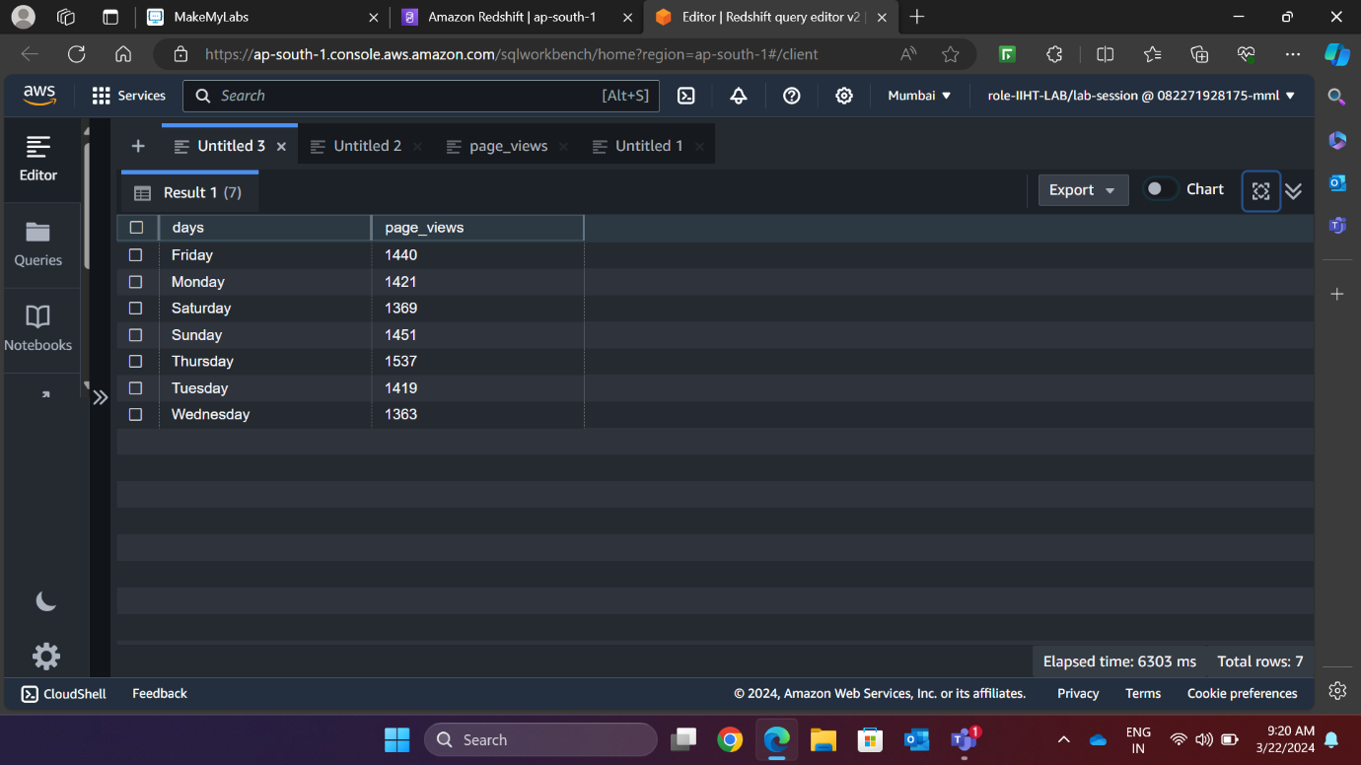

* **REQUIREMENT 5: Optimize website performance based on insights from traffic analysis.**

Optimizing website traffic on AWS involves several strategies that can be applied to any day of the week, including Thursdays. Here are some key points to consider:

[AWS Optimization: AWS optimization refers to the process of optimizing and improving the performance, reliability, and cost-effectiveness of workloads and resources running on the Amazon Web Services (AWS) cloud platform](https://granulate.io/blog/aws-optimization-basics-15-ways-to-optimize-cloud/).

[Cost Optimization: AWS cost optimization involves identifying and eliminating unnecessary expenses, optimizing resource utilization, and implementing cost-saving strategies1](https://granulate.io/blog/aws-optimization-basics-15-ways-to-optimize-cloud/). [Tools like AWS Cost Explorer and AWS Trusted Advisor can help identify cost-saving opportunities](https://granulate.io/blog/aws-optimization-basics-15-ways-to-optimize-cloud/).

[Performance Optimization: AWS performance optimization involves improving the speed, scalability, and overall performance of applications and infrastructure running on AWS1](https://granulate.io/blog/aws-optimization-basics-15-ways-to-optimize-cloud/). [This can be achieved by using appropriate instance types and sizes, implementing load balancing, and optimizing storage and network configurations](https://granulate.io/blog/aws-optimization-basics-15-ways-to-optimize-cloud/).

[Elastic Load Balancing: By using Elastic Load Balancing, you can ensure that traffic is evenly distributed and that instances are available to handle requests](https://granulate.io/blog/aws-optimization-basics-15-ways-to-optimize-cloud/).

[Autoscaling: Autoscaling allows you to automatically adjust your resources based on demand, ensuring that you’re not paying for more resources than necessary2](https://towardsaws.com/aws-cost-optimization-how-to-build-and-run-a-website-on-a-budget-8c029a10a535). [Configure your EC2 instances to scale up when traffic is high and scale down when traffic is low](https://towardsaws.com/aws-cost-optimization-how-to-build-and-run-a-website-on-a-budget-8c029a10a535).

[Scheduled Shutdowns and Terminations: Schedule shutdowns and terminations of resources that are only active during business hours or on weekdays by integrating AWS Instance Scheduler and Scheduled scaling for Amazon EC2 Auto Scaling](https://medium.com/@AllCode.aws/how-to-optimize-your-aws-services-for-maximum-efficiency-7be3e4198e3).

* **REQUIREMENT 6: Visualize website traffic data using charts and graphs (e.g., line graphs, heatmaps) to understand user behaviour and traffic patterns.**
* URL is plotted against its corresponding page views.

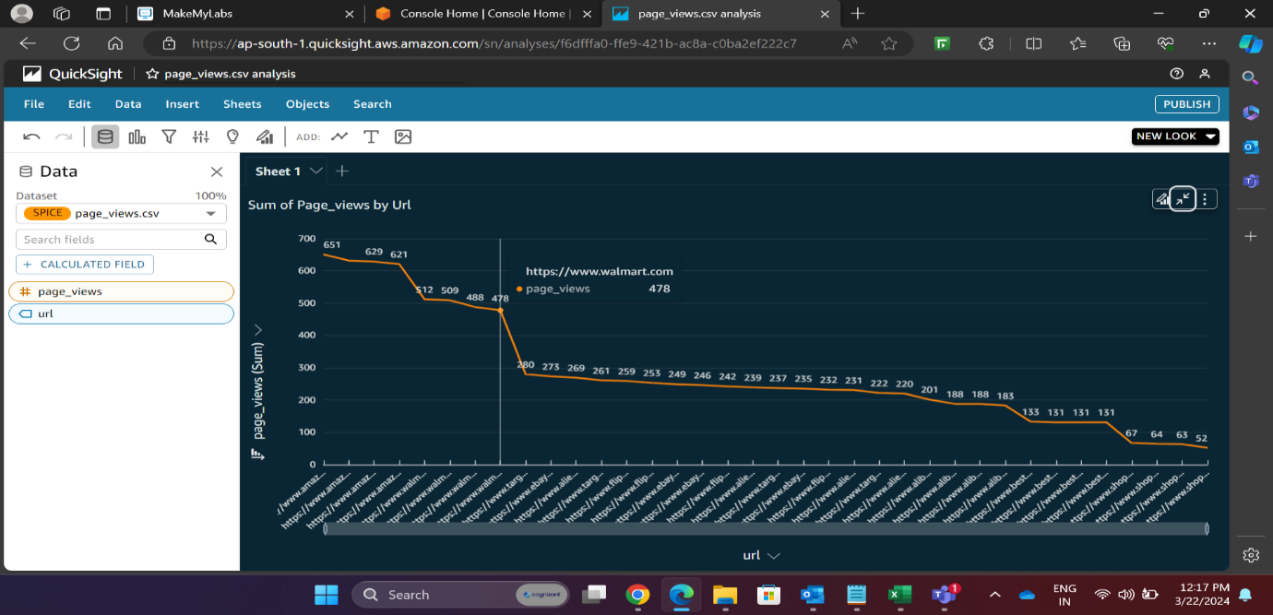

* URL is plotted against bounce rate.

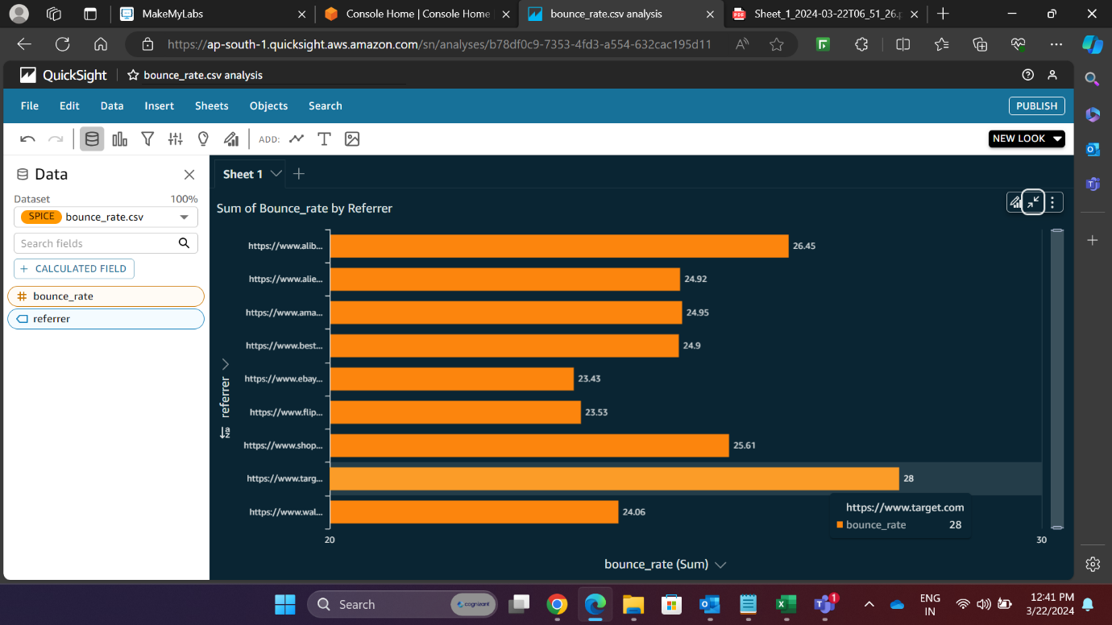

* Plot shows popular pages on basis of page visits.

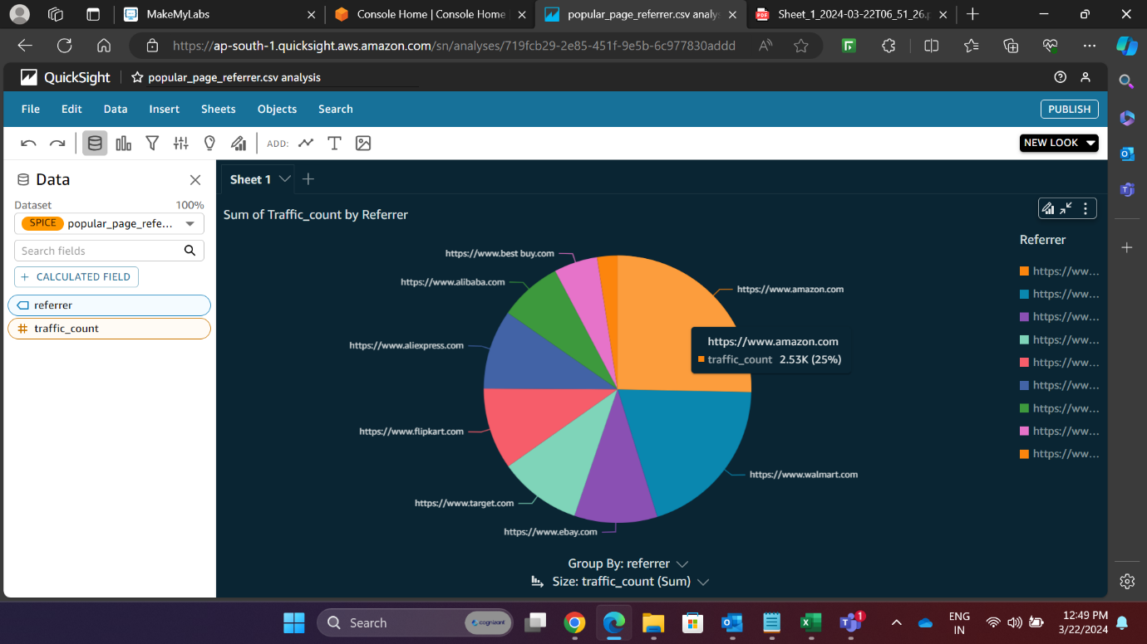

* Popular pages on the basis of average session duration.

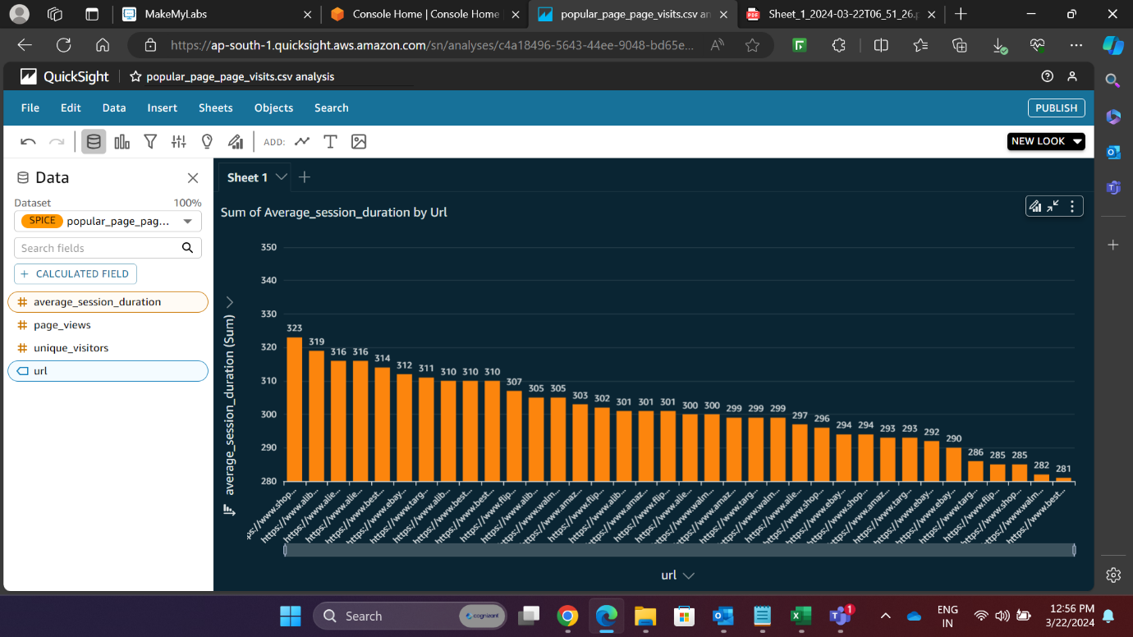

* Page views on daily basis.

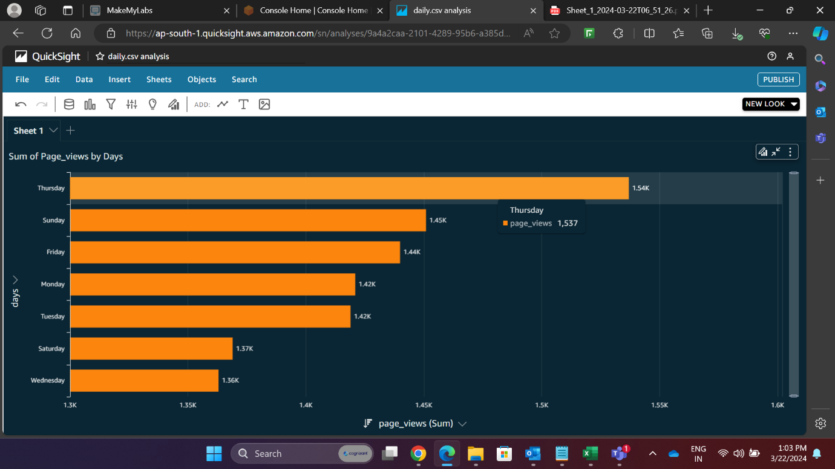

* Page views on hourly basis.

